Book3SS6-8 Notes错题
Wednesday, June 30, 2021
1:09 PM

2. Standard-setting bodies are responsible for:
A. establishing financial reporting standards only.
B. establishing and enforcing standards for financial reporting.
C. enforcing compliance with financial reporting standards only.
  - Standard-setting bodies are private-sector org that establish standards; enforcement is responsibility of regulatory authorities.

4. Dawn CX is writing an article about international financial reporting standards. In her article she states, “Despite strong support from business groups for a universally accepted set of financial reporting standards, disagreements among the standard-setting bodies and regulatory authorities of various countries remain a barrier to developing one.” CX's statement is:
A. correct.
B. incorrect, because business groups have not supported a uniform set of financial reporting standards.
C. incorrect, because disagreements among national standard-setting bodies and regulatory agencies have not been a barrier to developing a universal set of standards.
IASB and FASB aren't a uniform of standards.

3. International Accounting Standard (IAS) No. 1 least likely requires which of the following?
A. Neither assets and liabilities, nor income and expenses, may be offset unless required or permitted by a financial reporting standard.
B. Audited financial statements and disclosures, along with updated information about the firm and its management, must be filed at least quarterly. Not quarterly but annually
C. Fair presentation of financial statements means faithfully representing the firm’s events and 1. transactions according to the financial reporting standards. Financial statements must be presented at least annually. 2. Fair presentation is one of the IAS No. 1 principles for preparing financial statements. 3. The ban against offsetting is one of the IAS No. 1 principles for presenting financial statements.

4. Which of the following statements about the FASB conceptual framework, as compared to the IASB conceptual framework, is most accurate?
A. The FASB framework allows for upward revaluations of tangible, long-lived assets.
B. The FASB framework and IASB framework are now fully converged.
C. The FASB framework lists revenue, expenses, gains, losses, and comprehensive income related to financial performance. But IASB only lists income and expenses.

5. Rules-based and principles-based approaches to standard setting are:
A. each used for specific industries.
B. examples of coherent financial reporting frameworks.
C. an example of barriers to creating a coherent financial reporting framework.

6. Which is least likely one of the conclusions about the impact of a change in financial reporting standards that might appear in management’s discussion and analysis?
A. Management has chosen not to implement the new standard.
B. Management is currently evaluating the impact of the new standard.
C. The new standard will not have a material impact on the company’s financial statements.

2. Are income taxes and cost of goods sold examples of expenses classified by nature or classified by function in the income statement?
  - Income taxes are expenses grouped together by their nature. Cost of goods sold includes a number of expenses related to the same function, the production of inventory.

3. Which of the following is least likely a condition necessary for revenue recognition?
A. Cash has been collected.
B. The goods have been delivered.
C. The price has been determined.

6. A manufacturing firm sells a large amount of precision parts and provides financing to the buyer at its usual credit terms. The firm should recognize revenue from this transaction:
A. at the time of the sale.
B. using the installment method.
C. proportionally as payments are received.
  - For credit sales to its customers, the firm can recognize revenue at the time of the sale. The installment method would be appropriate if collectability could not be estimated reliably, and the cost recovery method would be appropriate if collectability was highly uncertain.

7. Which of the following statements about nonrecurring items is least accurate?
A. Discontinued operations are reported net of taxes at the bottom of the income statement before net income.
B. Unusual or infrequent items are reported before taxes above net income from continuing operations.
C. A change in accounting principle is reported in the income statement net of taxes after extraordinary items and before net income.
  - A change in accounting principle requires retrospective application; that is, all prior period financial statements currently presented are restated to reflect the change. (LOS 23.f)

  - The Hall Corporation had 100,000 shares of common stock outstanding at the beginning of the year. Hall issued 30,000 shares of common stock on May 1. On July 1, the company issued a 10% stock dividend. On September 1, Hall issued 1,000, 10% bonds, each convertible into 21 shares of common stock. What is the weighted average number of shares to be used in computing basic and diluted EPS, assuming the convertible bonds are dilutive?
The new stock is weighted by 8 / 12. The bonds are weighted by 4 / 12 and are not affected by the stock dividend. (1. LOS 23.h, 23.i)
Basic shares = {[100,000 × (12 / 12)] + [30,000 × (8 / 12)]} × 1.10 = 132,000
Diluted shares = 132,000 + [21,000 × (4 / 12)] = 139,000

3. Which of the following transactions affects owners’ equity but does not affect net income?
A. Foreign currency translation gain.
B. Repaying the face amount on a bond issued at par.
C. Dividends received from available-for-sale securities.
  - A foreign currency translation gain is not included in net income but increases owners’ equity. Dividends received are reported in the income statement, included in net income. The repayment of principal does not affect owners’ equity.(LOS 23.l, 23.m) Dividends paid | reacquisition of common stock are transactions with shareholders, not included in comprehensive income.

2. Which of the following statements about analyzing the balance sheet is most accurate?
A. The value of the firm’s reputation is reported on the balance sheet at amortized cost.
B. Shareholders’ equity is equal to the intrinsic value of the firm.
C. The balance sheet can be used to measure the firm’s capital structure.
  - The capital structure is measured by the mix of debt and equity(in BS) used to finance the business. (Module 24.2, LOS 24.b)

2. How should the proceeds received from the advance sale of tickets to a sporting event be treated by the seller, assuming the tickets are nonrefundable?
A. Unearned revenue is recognized to the extent that costs have been incurred.
B. Revenue is recognized to the extent that costs have been incurred.
C. Revenue is deferred until the sporting event is held.
  - The ticket revenue should not be recognized until it is earned. Even though the tickets are nonrefundable, the seller is still obligated to hold the event.

1. SF Corporation has created employee goodwill by reorganizing its retirement benefit package. An independent management consultant estimated the value of the goodwill at $2 million. In addition, SF recently purchased a patent that was developed by a competitor. The patent has an estimated useful life of five years. Should SF report goodwill and patent on its balance sheet?
Goodwill-NO, Patent-Yes
  - Goodwill developed internally is expensed as incurred. Purchased patent report on BS. LOS24.5e

  - 2. At the beginning of the year, Parent Company purchased all 500,000 shares of Sub Incorporated for $15 per share. Just before the acquisition date, Sub’s balance sheet reported net assets of $6 million. Parent determined the fair value of Sub’s property and equipment was $1 million higher than reported by Sub. What amount of goodwill should Parent report as a result of its acquisition of Sub? Purchase price of $7,500,000 [$15 per share × 500,000 shares] – fair value of net assets of $7,000,000 [$6,000,000 book value + $1,000,000 increase in property and equipment] = goodwill of $500,000, not $1,500,000. (Module 24.5, LOS 24.e)

  - 2. Selected data from Alpha Company’s balance sheet at the end of the year follows:
Investment in Beta Company, at fair value | $150,000
Deferred taxes | $86,000
Common stock, $1 par value | $550,000
Preferred stock, $100 par value | $175,000
Retained earnings | $893,000
Accumulated other comprehensive income | $46,000
The investment in Beta Company had an original cost of $120,000. Assuming the investment in Beta is classified as available-for-sale, Alpha’s total owners’ equity?
Total stockholders’ equity consists of common stock of $550,000, preferred stock of $175,000, retained earnings of $893,000, and accumulated other comprehensive income of $46,000, for a total of $1,664,000. The $30,000 unrealized gain from the investment in Beta is already included in accumulated other comprehensive income.

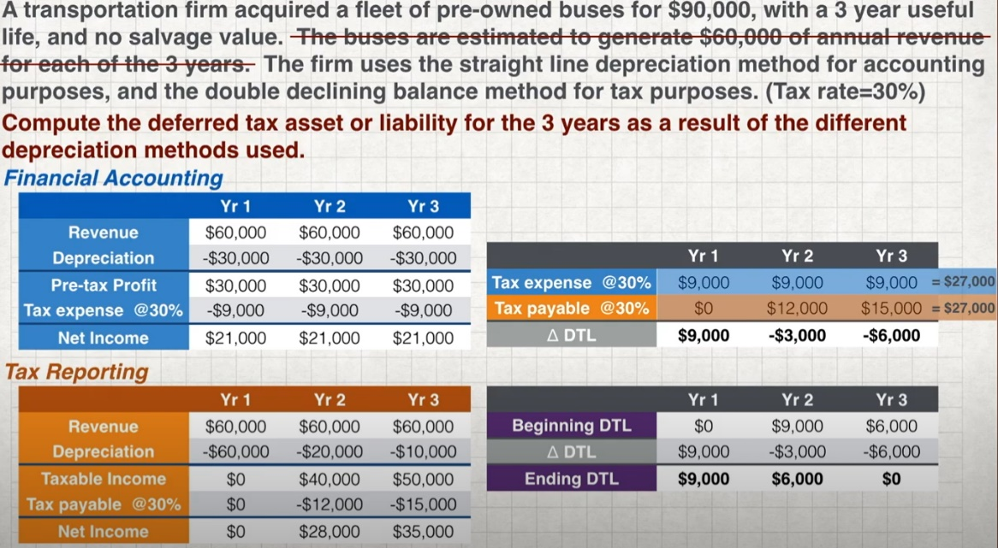

3. Which of the following is least likely a change in cash flow from operations under U.S. GAAP?
A. A decrease in notes payable. (this is a financing cash flow)
B. An increase in interest expense.
C. An increase in accounts payable.

1. Continental Corporation reported sales revenue of $150,000 for the current year. If accounts receivable decreased $10,000 during the year and accounts payable increased $4,000 during the year, cash collections were: A. $154,000. B. $160,000. C. $164,000.
  - $150,000 sales + $10,000 decrease in accounts receivable = $160,000 cash collections. The change in accounts payable does not affect cash collections. Accounts payable result from a firm’s purchases from its suppliers. (Module 25.3, LOS 25.f, 25.g)

6. A company’s current ratio is 1.9. If some of accounts payable are paid off from cash account:
A. numerator would decrease by a greater percentage than the denominator, resulting in a lower current ratio.
B. denominator would decrease by a greater percentage than the numerator, resulting in a higher current ratio.
C. numerator and denominator would decrease proportionally, leaving the current ratio unchanged.
  - Current ratio=CA/CL. If cash (a current asset) and AP (a current liability) decrease by same amount and current ratio is greater than 1, then the numerator decreases less in percentage terms than the denominator, and current ratio increases. (Module 26.2, LOS 26.b)

7. A company’s quick ratio is 1.2. If inventory were purchased for cash, the:
A. numerator would decrease more than the denominator, resulting in a lower quick ratio.
B. denominator would decrease more than the numerator, resulting in a higher current ratio.
C. numerator and denominator would decrease proportionally, leaving the current ratio unchanged.
  - Quick ratio = (cash + marketable securities + AR) / CL, not of inventory. (Module 26.2, LOS 26.b)

3. An analyst who needs to model and forecast a company’s earnings for the next three years would be least likely to:
A. assume that key financial ratios will remain unchanged for the forecast period.
B. use common-size financial statements to estimate expenses as a percentage of [net income]NO, but of SALES.
C. examine the variability of the predicted outcomes by performing a sensitivity or scenario analysis.

2. In a period of falling prices, a firm reporting under LIFO, compared to reporting under FIFO, will have a higher: A. cost of sales. B. gross profit margin. C. inventory turnover ratio.
  - With falling prices, LIFO COGS will include the cost of lower priced inventory and COGS will be less when compared to FIFO COGS. Because of this, the firm would report a higher gross profit margin under LIFO than under FIFO, while LIFO inventory will be higher and inventory turnover lower. (LOS 27.d)

3. Compared to reporting under FIFO for both tax and financial statements, a firm that chooses to report under LIFO during a period of falling prices would be most likely to report a lower:
A. inventory. B. gross profit. C. cash balance.
  - When prices are falling, LIFO would result in lower COGS (higher gross profit) and higher ending inventory than FIFO. Higher gross profit with LIFO would result in higher taxes payable which would reduce cash balances (as long they pay their taxes). (LOS 27.d)

2. Bangor Company discloses that its LIFO reserve was $625,000 at the end of the previous year and $675,000 at the end of the current year. For the current year, beginning inventory was $2,350,000 and ending inventory was $2,525,000. The firm’s tax rate is 30%. What would Bangor’s ending inventory have been using FIFO? A. $2,575,000. B. $2,997,500. C.$3,200,000.
FIFO inventory = LIFO inventory + LIFO reserve = $2,525,000 + $675,000 = $3,200,000, but I calculated the difference between LIFO reserves. (LOS 27.f)

2. According to U.S. GAAP, an asset is impaired when:
A. firm cannot fully recover the carrying amount of asset through operations.
B. accumulated depreciation plus salvage value exceeds acquisition cost.
C. present value of future cash flows from an asset exceeds it carrying value.
  - An asset is impaired when the firm cannot recover carrying value, C recoverability is tested based on undiscounted future cash flows. (LOS 28.i)

3. In the year after an impairment charge on a finite-lived identifiable intangible asset, compared to not taking the charge, net income is most likely to be: A. lower. B. higher. C. unaffected.
  - Because a finite-lived identifiable intangible asset would be amortized, amortization expense in the year after the reduction from the impairment charge would be lower (the carrying value of the asset would most likely be lower), increasing net income. (LOS 28.i)

3. A firm owns a warehouse that it rents out. Under IFRS, the firm may report the value of this asset on its balance sheet using:
A. the cost model or the fair value model.
B. the cost model or the revaluation model.
C. the revaluation model or the fair value model.
  - 区分revaluation跟fair value model，因为需要rent out forrental gains，所以其实是investment property - cost or fair value method under IFRS.

3. An analyst is comparing a firm to its competitors. The firm has a deferred tax liability that results from accelerated depreciation for tax purposes. The firm is expected to continue to grow in the foreseeable future. How should the liability be treated for analysis purposes?
A. It should be treated as equity at its full value.
B. It should be treated as a liability at its full value.
C. The present value should be treated as a liability with the remainder being treated as equity.
  - The DTL is not expected to reverse in the foreseeable future because a growing firm is expected to continue to increase its investment in depreciable assets, and accelerated depreciation for tax on the newly acquired assets delays the reversal of the DTL. (Module 29.2, LOS 29.b)

10. For analytical purposes, what is the impact on the debt-to-equity ratio if the market rate of interest increases after the bond is issued? A. An increase. B. A decrease. C. No change.
  - An increase in the market rate will decrease the price of a bond. For analytical purposes, adjusting the bond liability to its economic value will result in a lower debt-to-equity ratio (lower numerator and higher denominator). (Module 30.2, LOS 30.b)

2. The purpose of debt covenants is best described as:
A. limiting issuance costs.
B. preventing technical default.
C. protecting the interests of creditors.
  - A bond is considered to be in “technical” default if the borrower violates the bond’s covenants

3. Which of the following is least likely to be disclosed in the financial statements of a bond issuer? A. The amount of debt that matures in each of the next five years.
B. Collateral pledged as security in the event of default.
C. The market rate of interest on the balance sheet date.
  - The market rate on the balance sheet date is not typically disclosed. The amount of debt principal scheduled to be repaid over the next five years and collateral pledged (if any) are generally included in the footnotes to the financial statements. (LOS 30.e)

2. Under IFRS 16, a lease for a period of more than one year may be classified as an operating lease by: A. lessors only. B. lessees only. C. both lessors and lessees.
  - Under IFRS 16, lessors may classify leases as operating or finance leases, but lessees must treat all leases longer than one year as finance leases.(Module 30.4, LOS 30.h)

3. At the beginning of 20X6, Cougar Corporation enters a finance lease requiring five annual payments of $10,000 each beginning on the first day of the lease. Assuming the lease interest rate is 8%, the amount of interest expense recognized by Cougar in 20X6 is closest to:
A. $2,650. B. $3,194. C. $3,450.
  - At the inception of the lease, the present value of the lease payments is $43,121 (BGN mode: N = 5, I = 8, PMT = 10,000, FV = 0, solve for PV). After the first payment is made, the balance of the lease liability is $43,121 – 10,000 principal payment = $33,121. Interest expense for the first year is $33,121 × 8% = $2,650. (Module 30.4, LOS 30.h)

